GROUP DOCUMENTATION

MODULE NAME: INTRODUCTION TO DATABASE

MODULE INTAKE CODE: CT042-3-1

INTAKE CODE: APD1F2311

LECTURER NAME: LAI CHEW PING

PROJECT TITLE: MALAYSIA TRAIN RESERVATION SYSTEM

|  |  |  |
| --- | --- | --- |
| **No.** | **Student Name** | **TP Number** |
| 1. | Ruba Munaf Hasan Alshaikh | TP078528 |
| 2. | Manreen Kaur A/P Jagjit Singh | TP071290 |
| 3. | Mohammed Baduruddin Haitham | TP076927 |
| 4. | Ahmed AlaaEldin Mohmed Elhusseini Seada | TP077921 |

Leader Name: Ruba Munaf Hasan Alshaikh

Contents

d) Database Schema 3

• Entity Relationship Diagram. 3

• Generate the database diagram from the DBMS. 4

e) SQL – Data Definition Language (DDL) 5

• Create all tables with suitable attributes and data types. 5

• Screenshot all query statements. 5

d) Database Schema 22

• Entity Relationship Diagram. 22

• Generate the database diagram from the DBMS. 22

e) SQL – Data Definition Language (DDL) 22

• Create all tables with suitable attributes and data types. 22

• Screenshot all query statements. 22

## Database Schema

Manreen Kaur (TP071290)

### Entity Relationship Diagram.

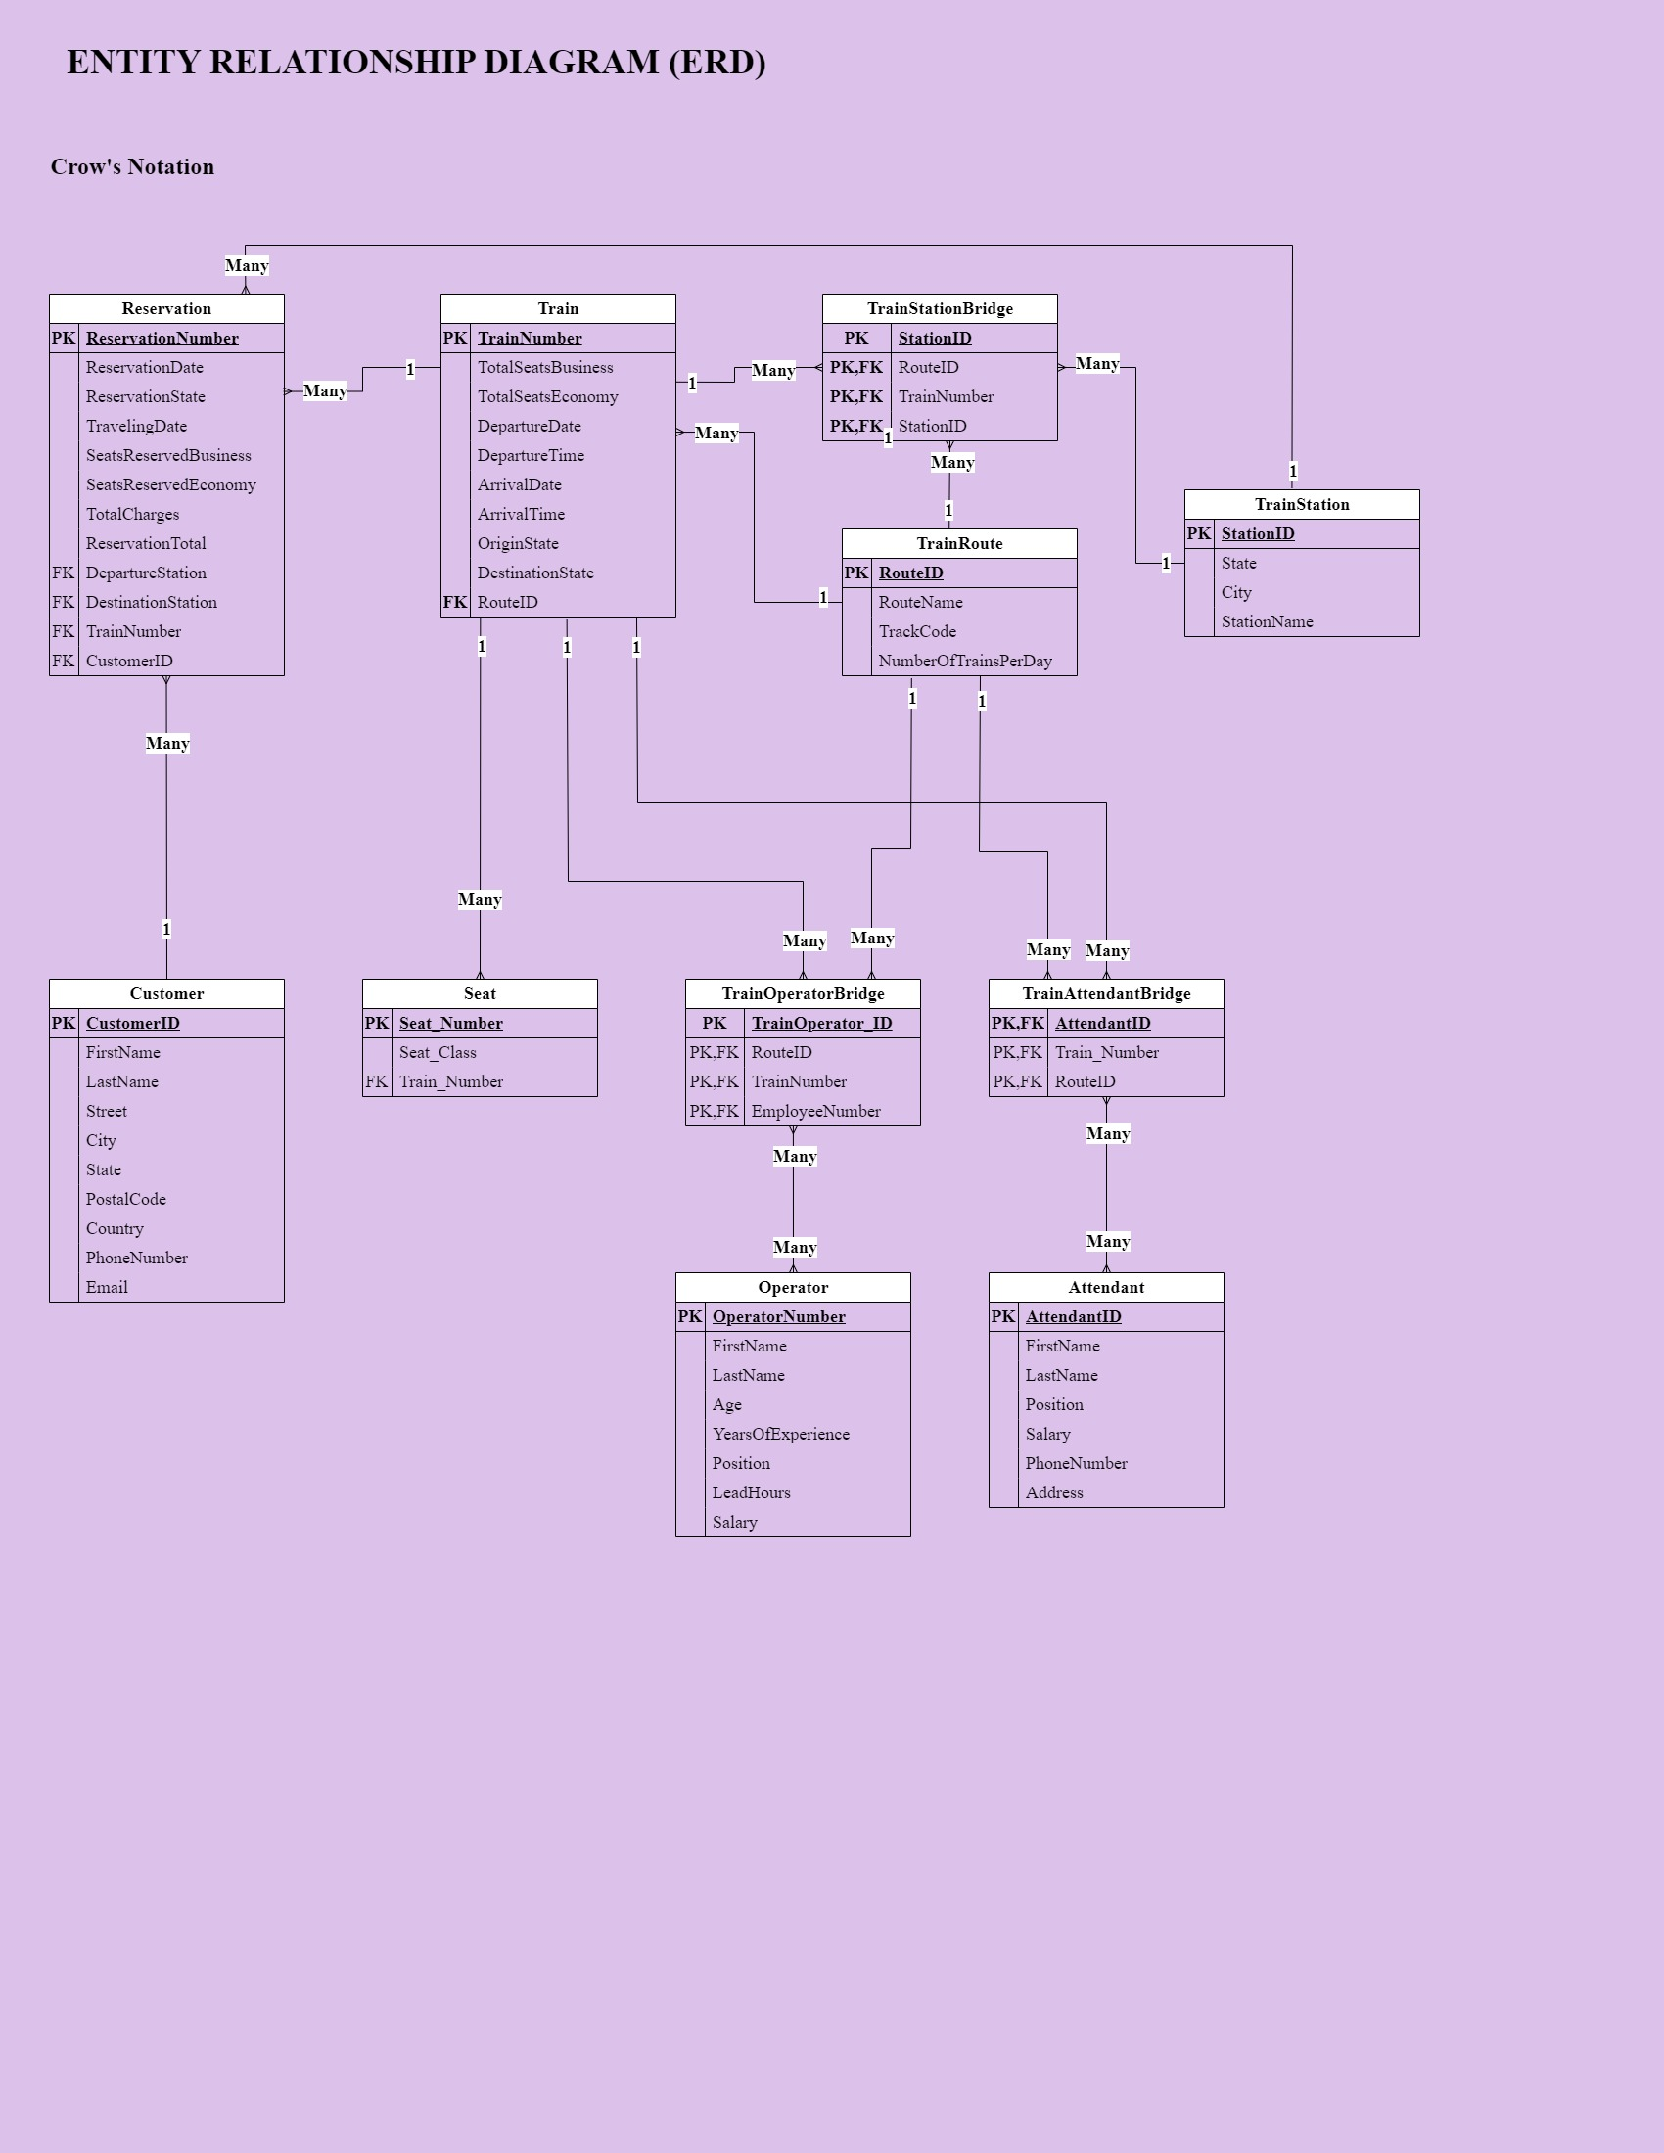

Entity Relationship Diagram

This Entity Relationship Diagram is made to update the previous Entity Relationship after constructing the query statements in the SQL database server based on the Train Reservation system requirements. This diagram includes entities, attributes, and relationships.

### Generate the database diagram from the DBMS.

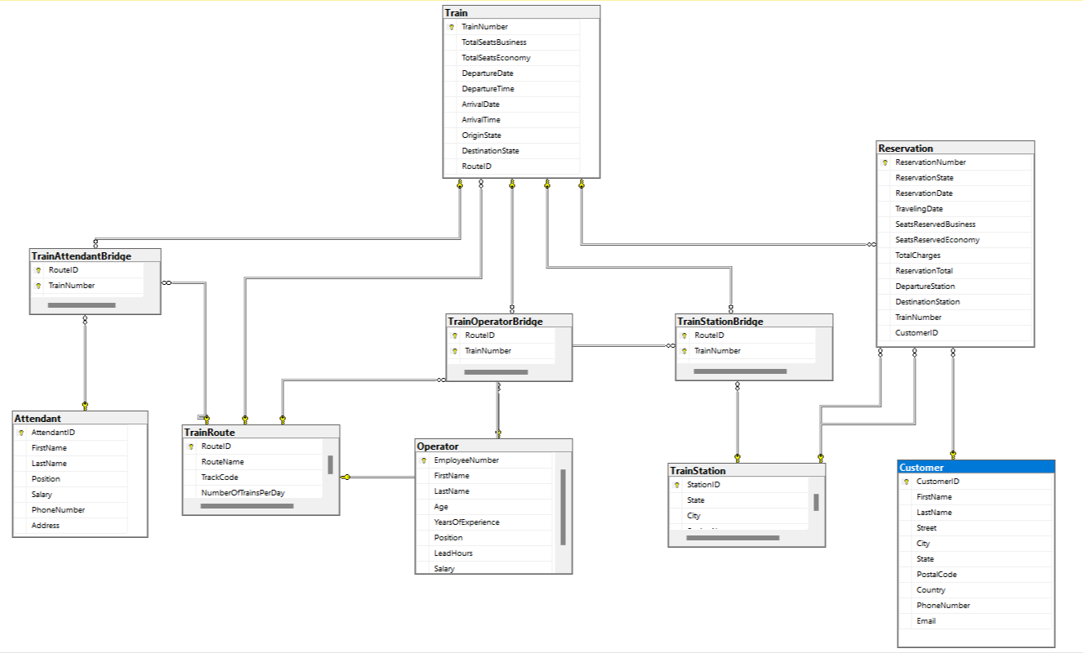

Database Diagram DBMS

This Entity Relationship Diagram is designed by the SQL database server based on the queries made. This diagram demonstrates the relationship between entities with their attributes.

## SQL – Data Definition Language (DDL)

Manreen Kaur (TP071290)

### Create all tables with suitable attributes and data types.

### Screenshot all query statements.

The queries are made based on the entities that are involved in the system. This query includes values such as Primary key, integer, and more.

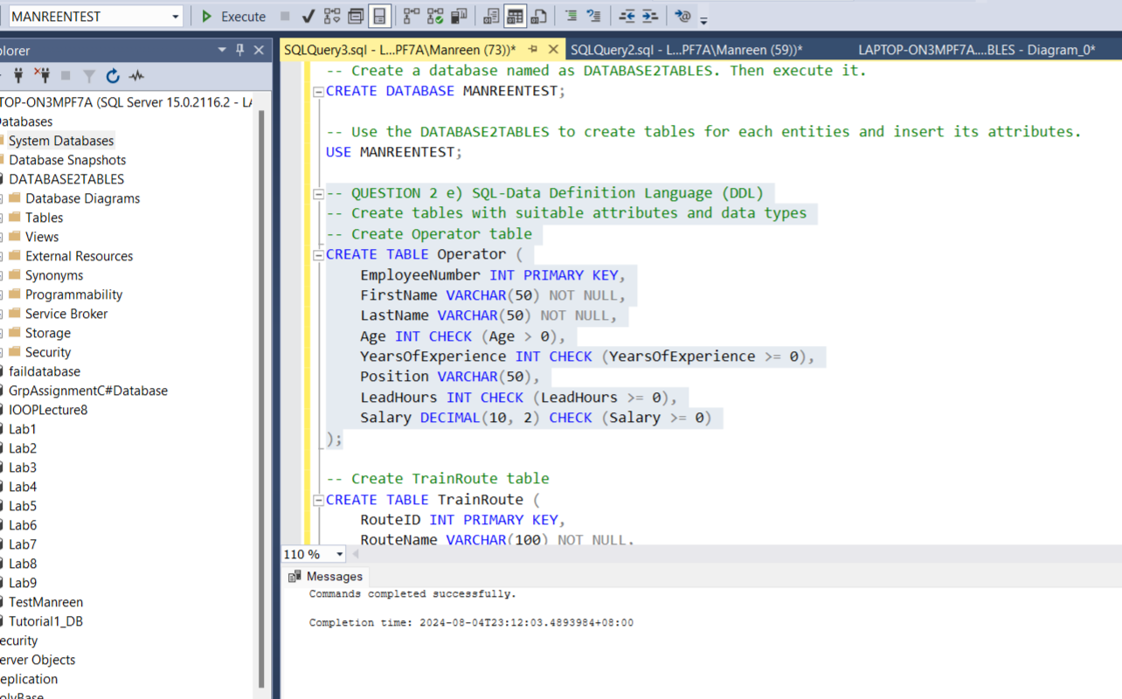

Query statements

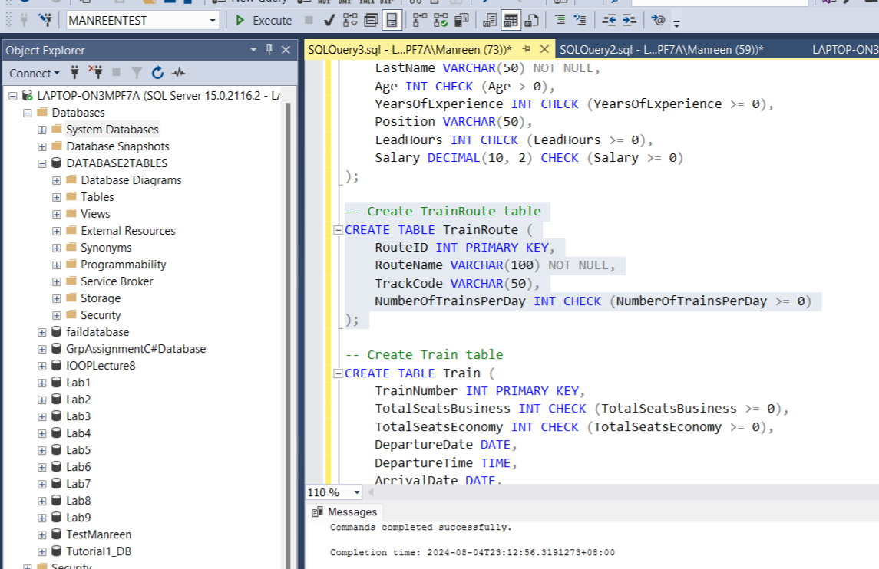

Query statements

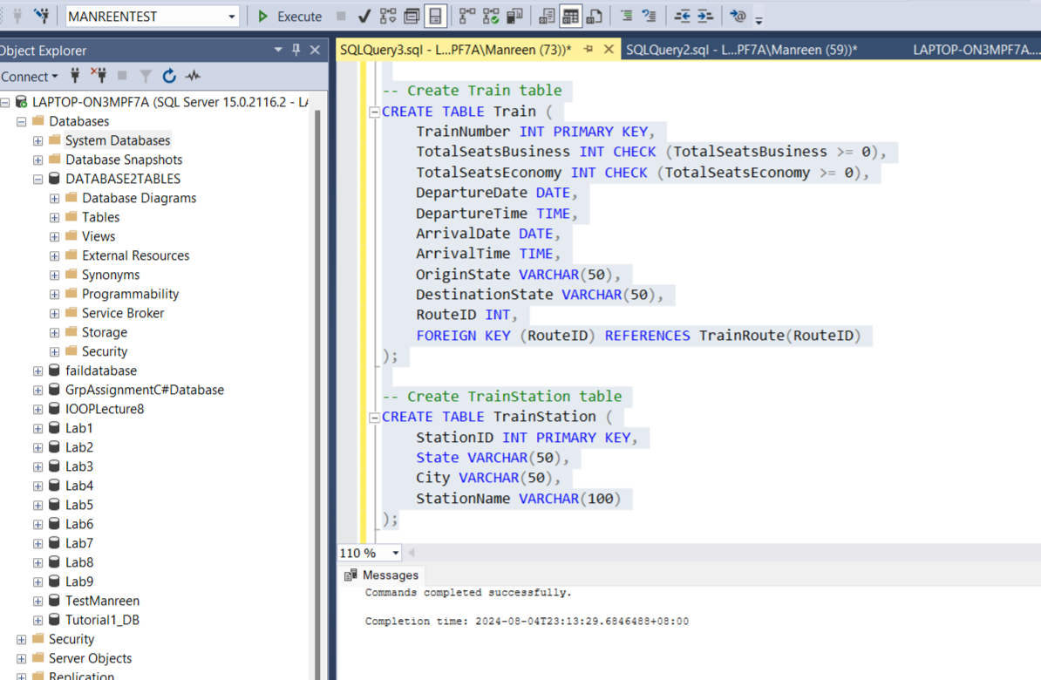

Query statements

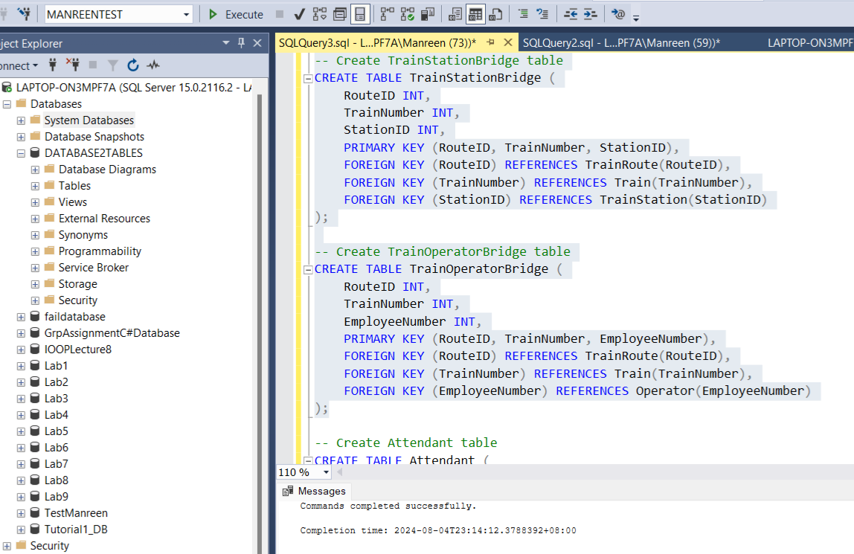

Query statements

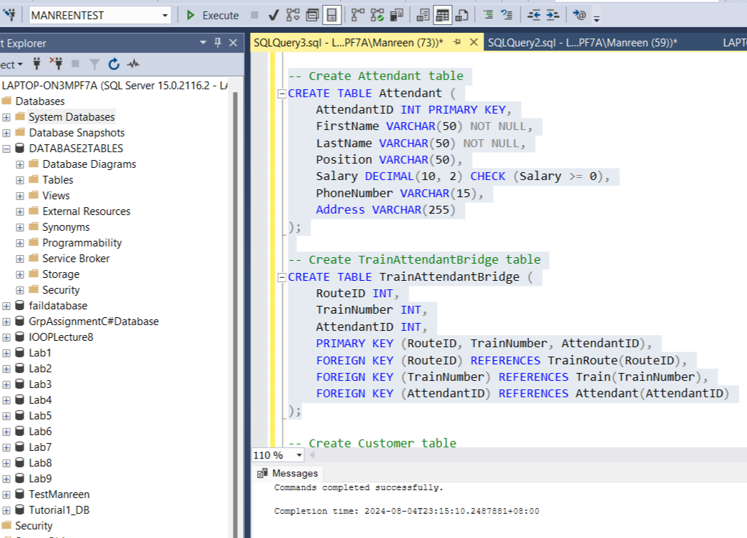

Query statements

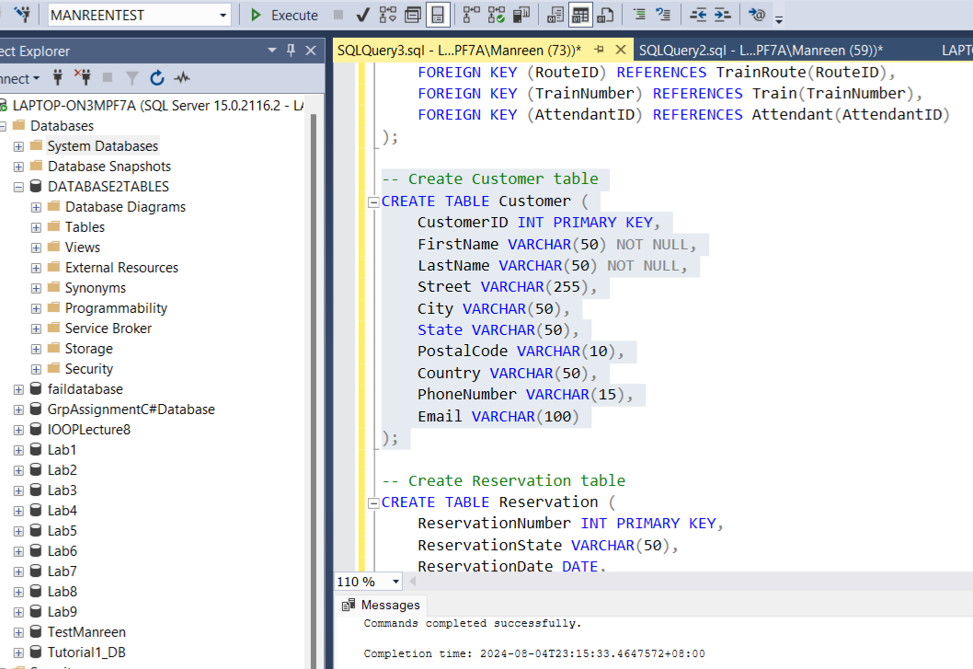

Query statements

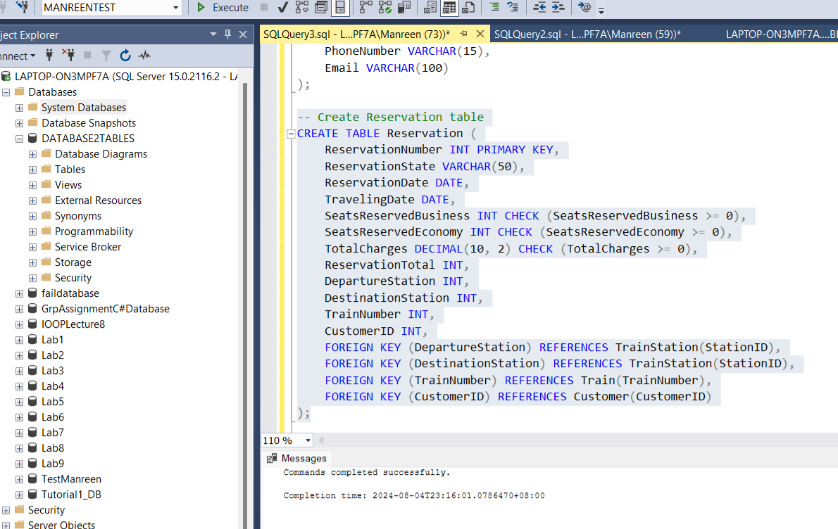

Query statements

* Screenshot all tables with their data.

The screenshot below are the tables with the data that is made in the system.

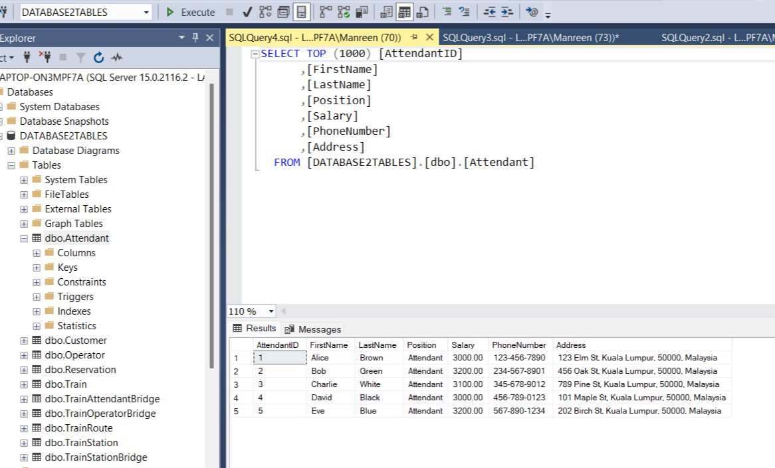

Tables with data

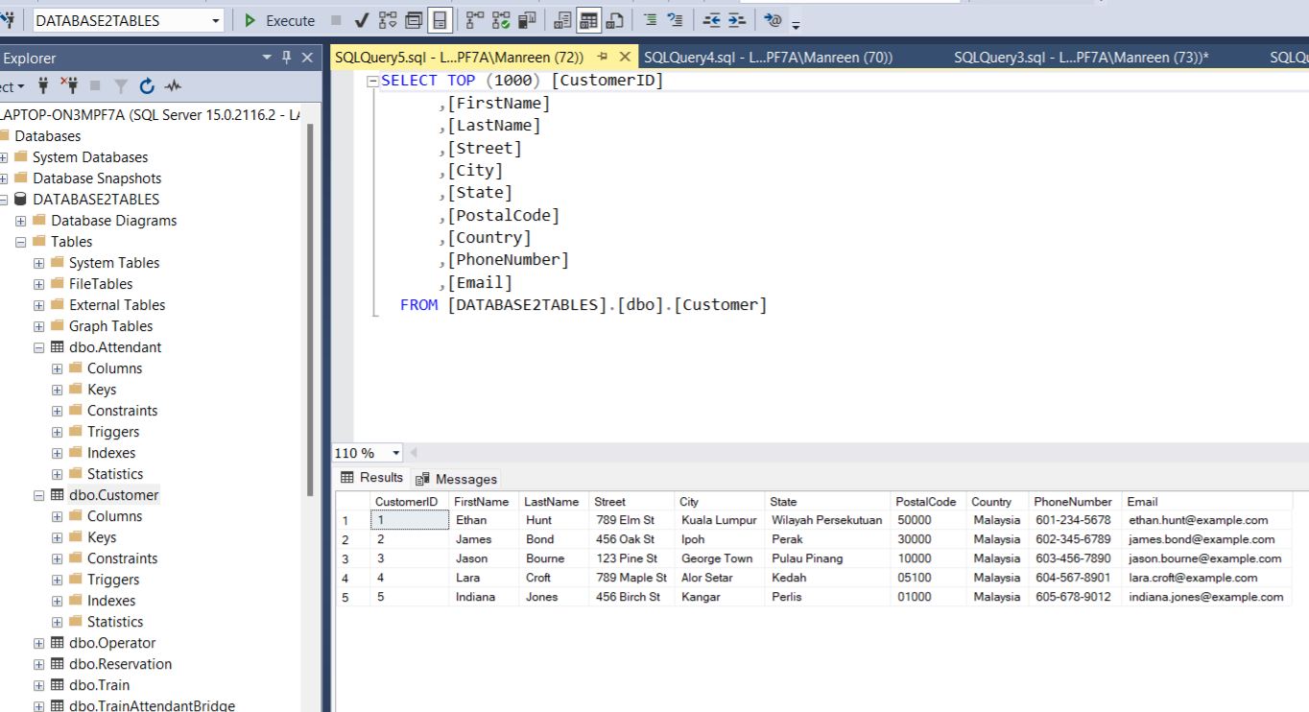

Tables with data

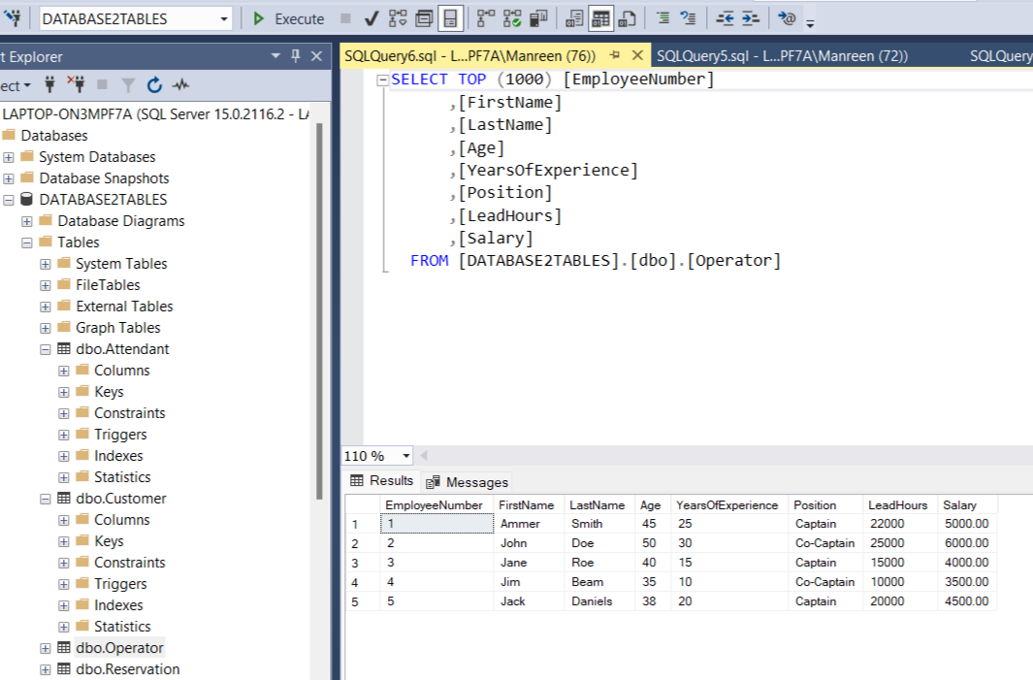

Tables with data

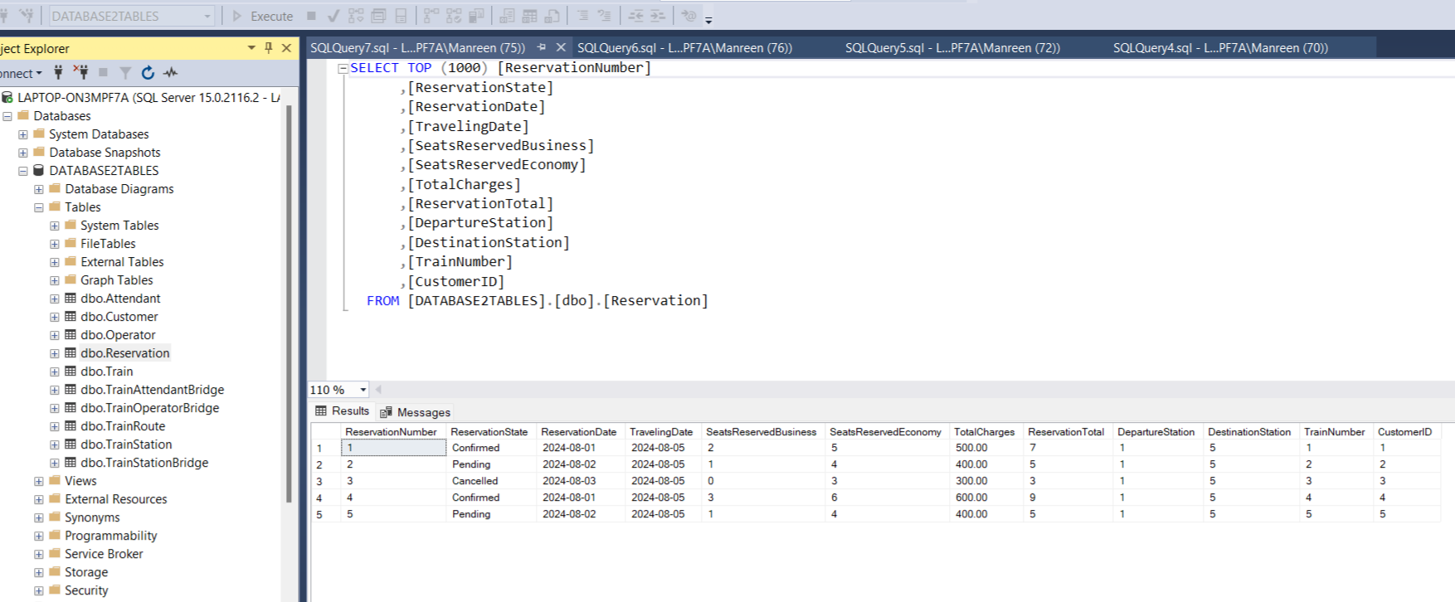

Tables with data

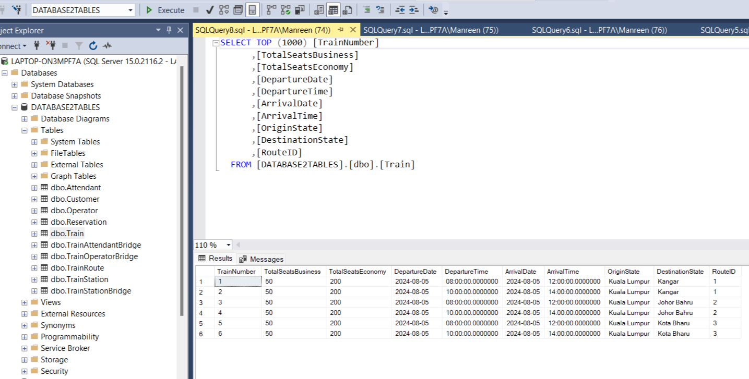

Tables with data

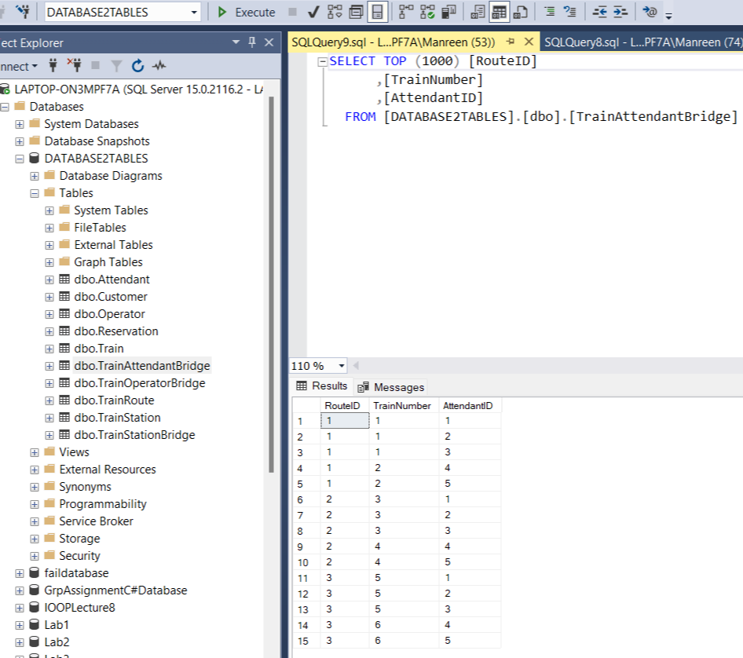

Tables with data

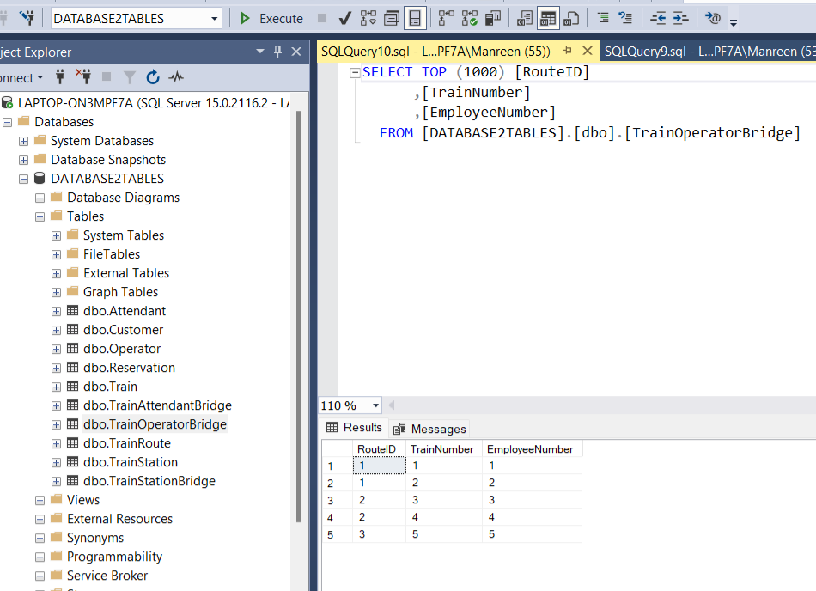

Tables with data

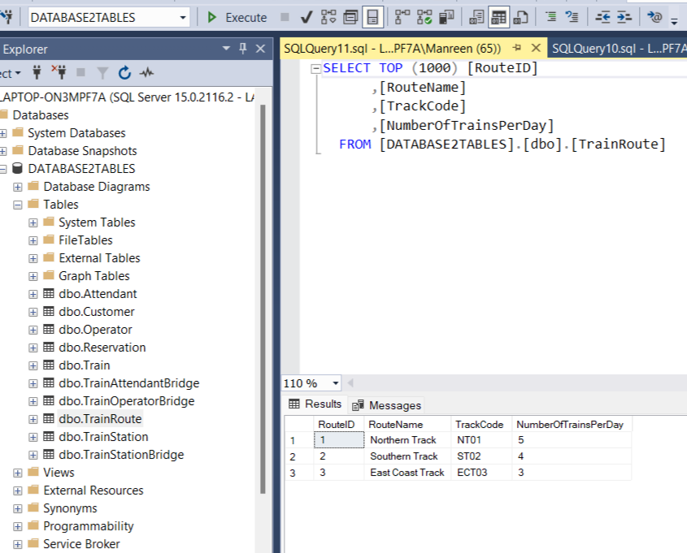

Tables with data

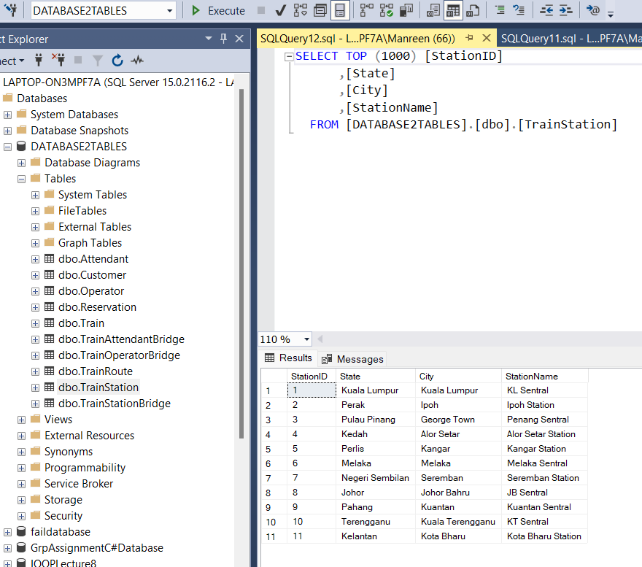

Tables with data

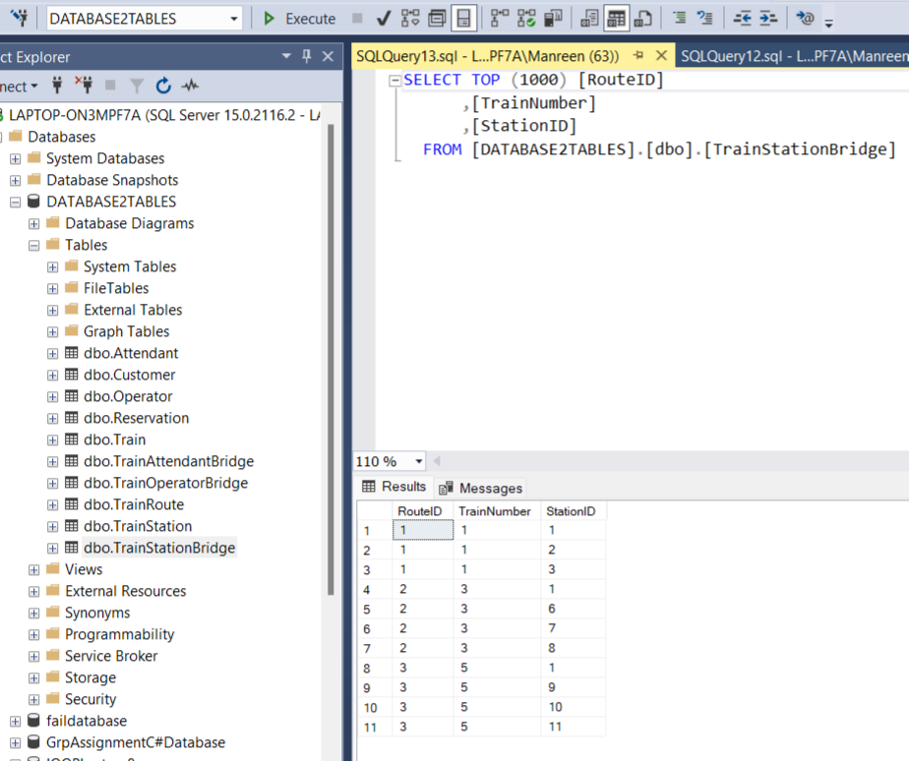

Tables with data

2 f) SQL-Data Manipulation Language (DML)

Member 1: (Ruba Munaf Hasan ) (QUESTION 1-4)

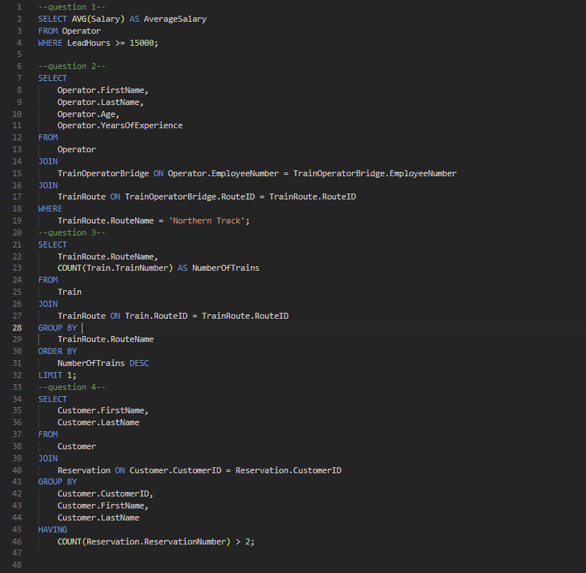

Member 2: (Mohammed Badruddin Haitham) (QUESTION 5-8)

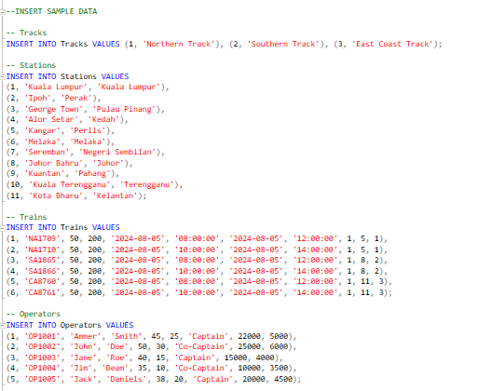

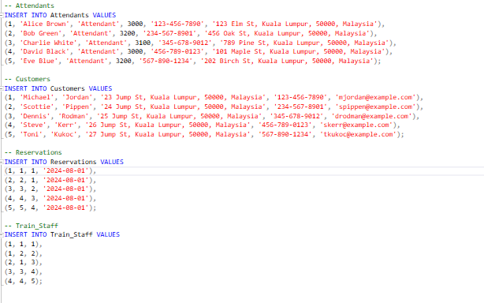

Q5)

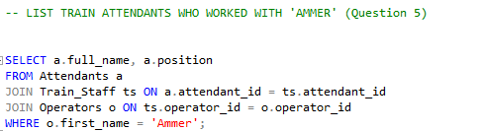

Q6)

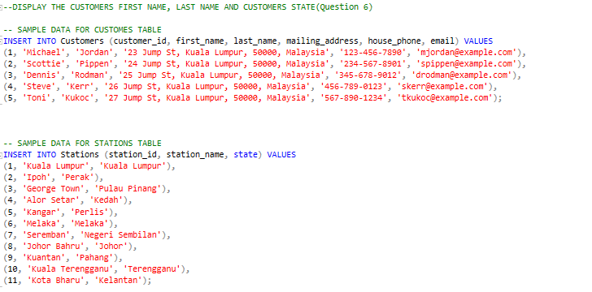

Q7)

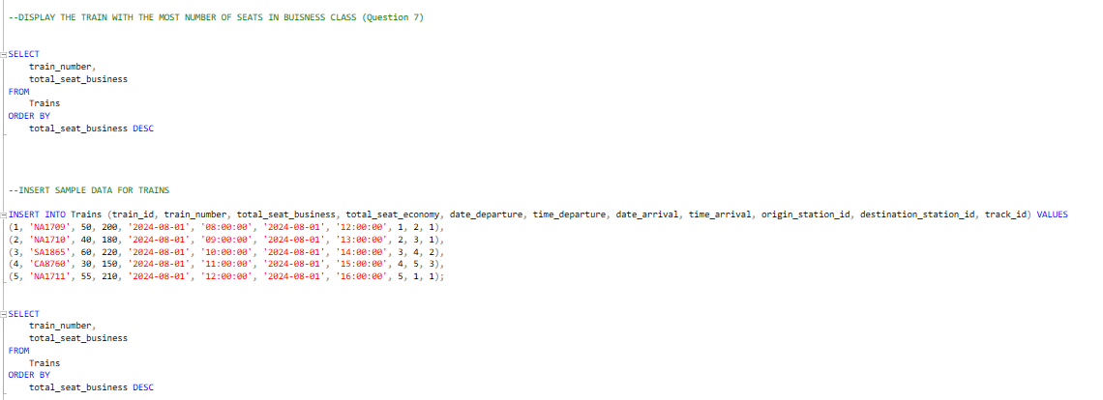

Q8)

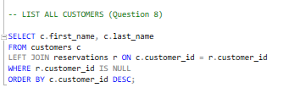

Member 3: (Ahmad Alaa ) (QUESTION 9-12)

Q9

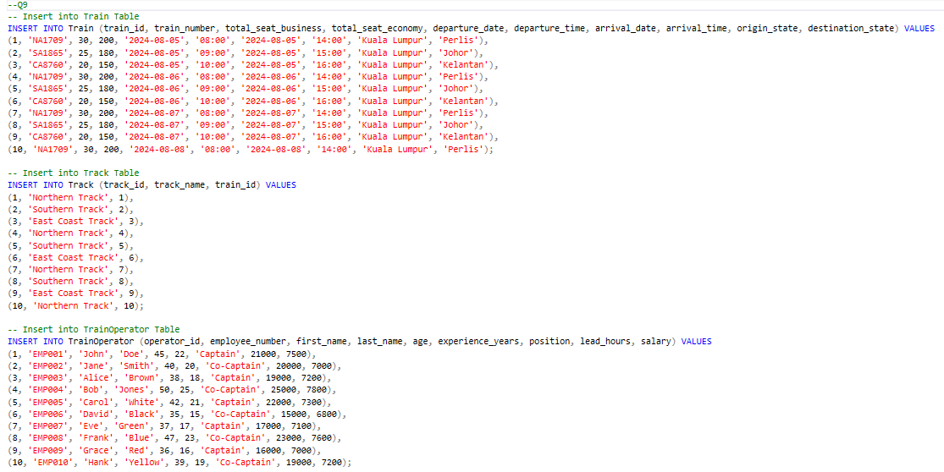

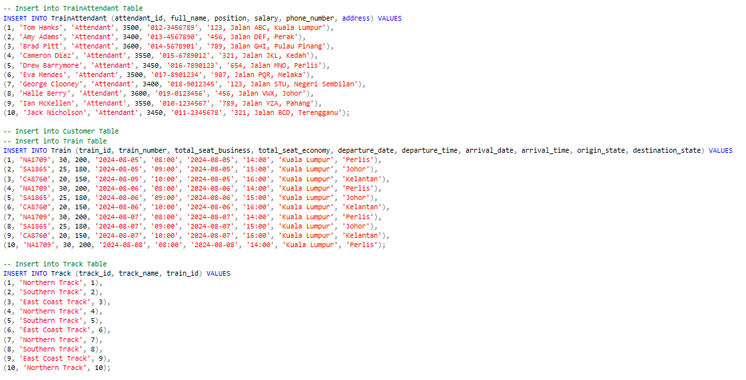

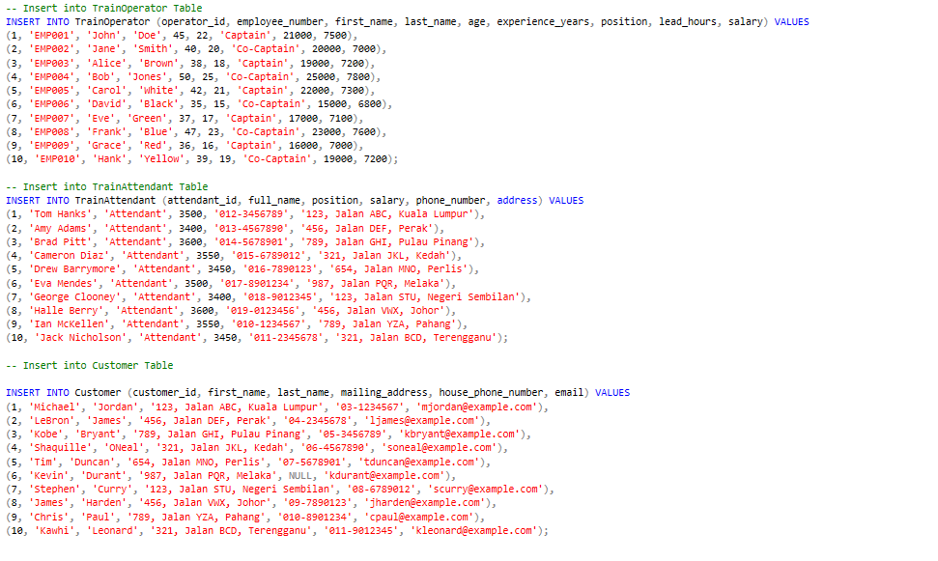

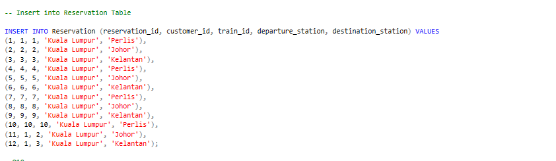

Q10



Q11

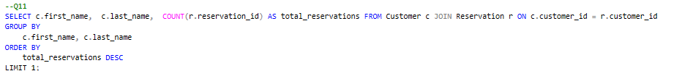

Q12



Result for all the questions (1-12)

